Lucas Swanson
4/26/2025
Software Engineering Methods
Exercise 4.3
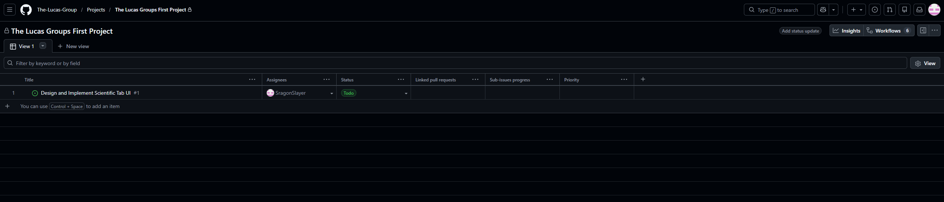
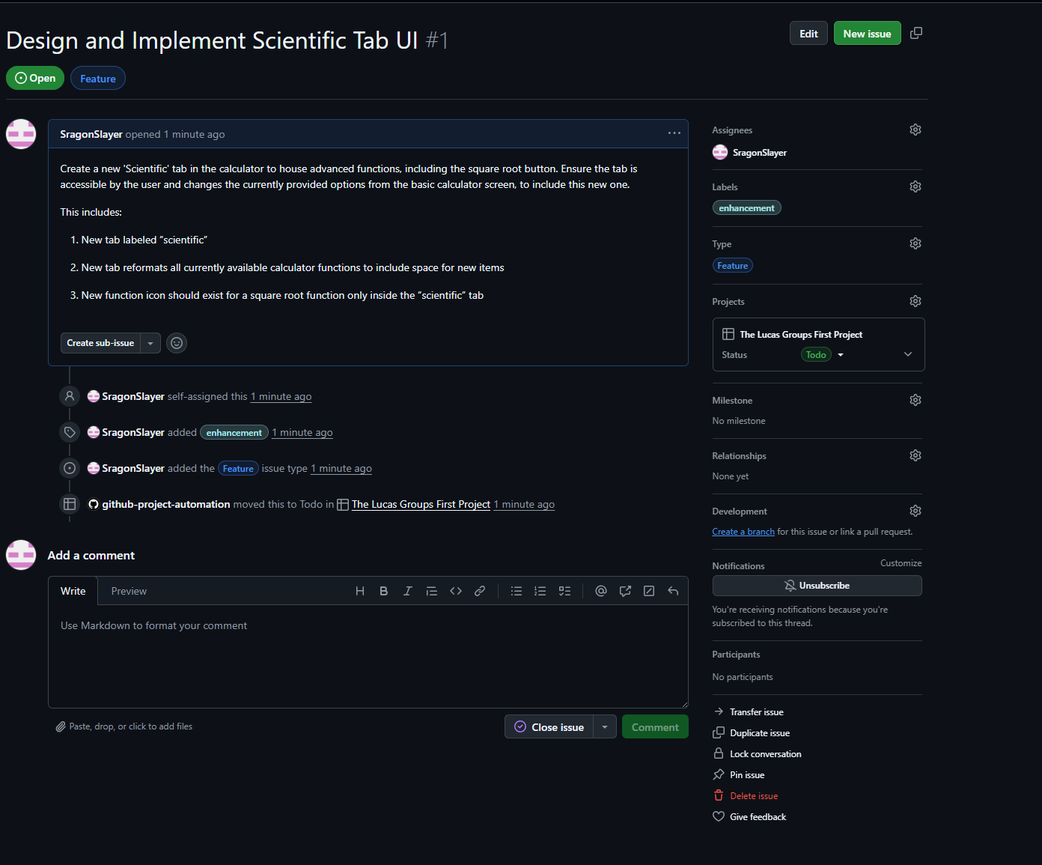
- Useful features: Based on your exploration, which one GitHub Projects or Issues feature do you think will be most valuable for your team during the Team Lab this week, and why?
  - I think mostly the table view on github projects would be the most useful for the team to see what is going on for the lab this week.
However this does leave me with the question on how can we link all of the actions the team is doing across Jira or GitHub? Is there not a way to have all of the stories made in Jira link to the specified project in GitHub?
- Surprises or friction: Was there anything about GitHub Projects or Issues that surprised you, confused you, or worked differently than you expected?
  - It is not that bad to use GitHub projects, and more simple interface when compared to Jira I think. However I am not sure how I can link my actual work to a GitHub issue I have made. At least in Jira I can link the exact story name my github branch is attempting to fix, would I in contrast, use the issue itself to make commits towards main?
- Jira vs. GitHub: Having now explored both tools, which do you personally prefer for managing a software project, and why? Consider factors such as ease of use, features, and integration with your existing workflow.
  - I think for managing a software project Jira is superior in large scale tracking as I can easily see with all of the different menu’s, filters, grabbing stories from multiple groups and sections all at once could benefit a company trying to align many different software departments at once and see the performance and progress of each independently.
- Open question (optional): What is one thing about GitHub Projects or Issues you would like to understand better after this exploration?
  - I am still stuck on the GitHub project one. How can I take an issue that is assigned to me, make progress on the issue, complete it, and ensure all progress is traceable to the issue that I have been working on? I am aware of how to do this on Jira, but not GitHub projects.

